|  |
| --- |
| PS2Win |
| Weekly Report |
| Keep Your Time |

|  |
| --- |
| Carla Machado;Filipe Brandão  29-03-2013 |

**Team Members:**

Carla Machado

David João

Filipe Brandão

João Girão

João Martins

Mário Oliveira

Rui Ganhoto

**Week 5**, 18th of March to 03th of April

Content

1. Week Activities 1

1.1. Work Executed 1

1.2. Work Analyses 1

1.3. Achievements 1

2. Impediments 1

3. Plans For Next Week 2

4. Progress 2

4.1. Earned value and/or Gantt Image 2

4.2. Effort by task 3

4.3. Individual effort 3

5. Individual log 4

**Images**

**Não foi encontrada nenhuma entrada do índice de ilustrações.**

**Tables**

Table 1: List of Contributors ii

Table 2: Version history ii

Table 3: Log of individual effort 4

|  |  |  |  |
| --- | --- | --- | --- |
| **Authors and Contributors** | | | |
| **Date** | **Name** | **Contacts** | **Contribution** |
| 29-03-2013 | Carla Machado | a21170460@alunos.isec.pt | Author |
| 04-04-2013 | Filipe Brandão | a21180276@alunos.isec.pt | Author |
|  |  |  |  |
|  |  |  |  |
|  |  |  |  |

Table 1: List of Contributors

|  |  |  |  |  |  |
| --- | --- | --- | --- | --- | --- |
| **Revision History** | | | | | |
| **Date** | **Description** | **Author** | **Version** | **Approvers** | **State** |
| 29-03-2013 | Creation of first draft | Carla Machado | 0.1 |  | Draft |
| 03-04-2013 | Continuation of the draft | Carla Machado | 0.2 |  | Draft |
| 04-04-2013 | Continuation (added graphs) | Filipe Brandão | 0.3 |  | Draft |
|  |  |  |  |  |  |
|  |  |  |  |  |  |
|  |  |  |  |  |  |
|  |  |  |  |  |  |
|  |  |  |  |  |  |
|  |  |  |  |  |  |
|  |  |  |  |  |  |
|  |  |  |  |  |  |
|  |  |  |  |  |  |

Table 2: Version history

# Week Activities

# Work Executed

* Corrections to the Requirements Analysis Process and approval
* Verification & Validation Process ready for Review and reviewed
* Corrections, revision and approval of the Review Process
* Initiation of the project plan and the quality plan
* Small changes to the dashboard and logs
  + New column in the total effort by member - Expected
  + New task type – Research/Study
* Progress in the definition of the Project Assessment and Control Process

# Work Analyses

The work week had some questions of efficiency that could have been better namely in regards to the work coordination between members. An example was the review and approval of the Project Planning Process that although the effort spent on it wasn’t much the length of time was considerable.

# Achievements

* Requirements Analysis Process is baselined
* Review Process is baselined

# Impediments

This week there were some difficulties and impediments such as

* Definition of the Project Assessment and Control Process keeps difficulty in defining the process itself and organizing the document contents – mental blockage
* Definition of the quality plan namely in deciding the quality attributes and how to assure their presence

# Plans For Next Week

* Approval of the Project Planning Process
* Verification and Validation Process ready for approval
* Project Assessment and Control Process
* Finishing the project and quality plans
* Start Requirements analysis

# Progress

# Earned value and/or Gantt Image

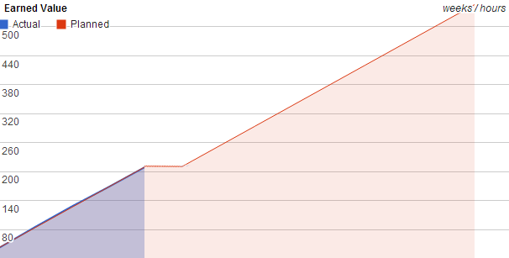

Figura - Earned Value

Planned = 210

Actual = 209.5

# Effort by task

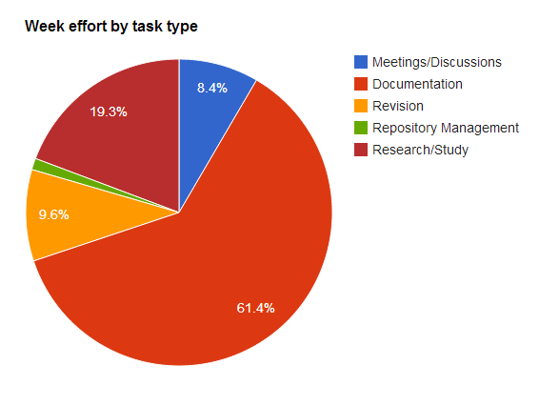

Figura - Effort by task type

# Individual effort

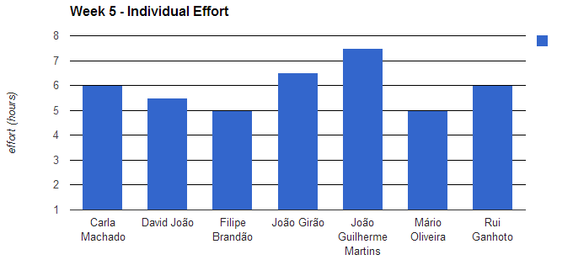

Figura - Individual Effort

|  |  |
| --- | --- |
| **Name** | **Effort(hours)** |
| Carla Machado | 6 |
| David João | 5.5 |
| Filipe Brandão | 5 |
| João Girão | 6.5 |
| João Martins | 7.5 |
| Mário Oliveira | 5 |
| Rui Ganhoto | 6 |

Table 3: Log of individual effort

# Individual log

**Carla Machado - Tasks done:**

* Requirements Analysis Process – 0.5h
* Documents reviews – 1h
* Discussions – 0.5h
* Research on Quality Plans – 1.5h
* Writing of the Quality Plan – 1h
* Next meeting agenda – 0.5h
* Writing of the Weekly Report – 1h

**David João - Tasks done:**

* Discussion about the Project Assessment and Control Process – 1h
* Writing of Project Assessment and Control Process – 4.5h

**Filipe Brandão - Tasks done:**

* Writing meeting minute – 0.5h
* Corrections to the Project Planning Process – 1h
* Discussions – 0.5h
* Start of the project planning – 1h
* Changes to Logs and corrections to the Dashboard – 0.5h
* Correction to Review Process – 1h
* Weekly Report – 0.5h

**João Girão - Tasks done:**

* Requirements Analysis Process – 0.5h
* Study and planning of the Verification and Validation Process – 2h
* Writing of the Verification and Validation Process – 4h

**João Martins - Tasks done:**

* Changes to the Project Planning Process – 1h
* Study of Verification and Validation Processes – 4h
* Writing of the Verification and Validation Process – 2h
* General Discussions – 0.5h

**Mário Oliveira - Tasks done:**

* Discussion about the Project Assessment and Control Process – 0.5h
* Writing of Project Assessment and Control Process – 2h
* Corrections to the Review Process – 1.5h
* Approval to the Requirements Analysis Process – 0.5h
* Revision of the Verification & Validation Process – 0.5h

**Rui Ganhoto - Tasks done:**

* Approval o meeting minute – 0.5h
* Checking and analyzing scheduled times in the agenda – 0.5h
* Revision of the Requirements Analysis Process – 1h
* Discussion about the Project Assessment and Control Process – 0.5h
* Helping in the writing of the Project Assessment and Control Process – 0.5h
* Reordering and corrections of the document of the Project Assessment and Control Process – 1.5h
* Approval of the Review Process – 0.5h
* Research on coding standards – 0.5h
* Writing of an auxiliary document for production of a coding standards document – 0.5h